

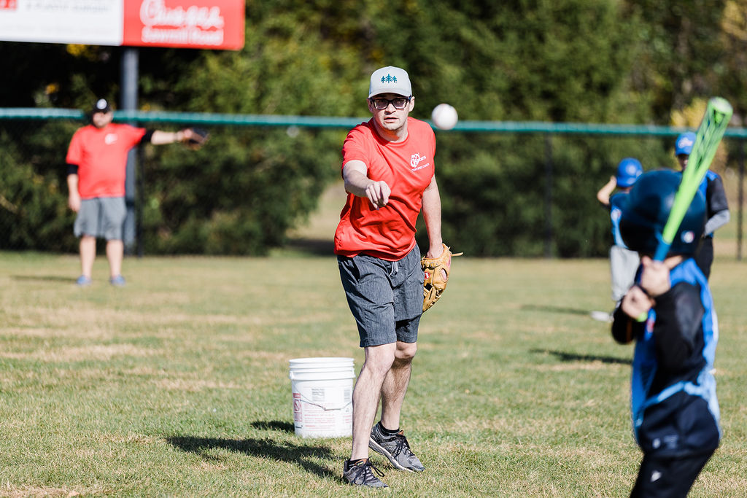

7U Coaches Handbook
Spring 2026

Introduction:
This handbook is designed to support volunteers in running fun and active practices / games that provide players and coaches a positive season. Volunteers are the backbone of PGYBA, so we hope this helps prepare you for the season to come.
Positive energy, cheering, and high fives when players cross home plate go a long way to achieving our goals. Best wishes for a fun season.
7U Goals:
- Minimize downtime at the younger ages
- Familiarize players with how to stand / swing in relation to home plate
- Timing a tossed ball in preparation for hitting
- Watching & Fielding a batted ball
- Basic Knowledge of Rules / Gameplay
  - Direction of the bases
  - Throwing to 1st Base
- FUN!!!

Field Set-Up / Management
- Place portable bases approx. 50 feet apart (15-17 paces)
- Recruit / Invite 2-4 Parents to assist on-field at catch balls at first base, direct players to run to the next base, keep kids waiting to hit ready and organized
  - ****Anyone on the field must be registered with the league and have a valid criminal records check. Please have parents and helpers start this process ASAP at the start of the season***
- The Fielding team is set up in the standard infield positions, including next to the coach at the pitching position; no outfielders or catchers are used at this age
  - Rotate players to a new position each inning
- The Hitting team stands along the fence / sideline and must be wearing their batting helmets (please have a willing parent monitor the line-up if available
- Field Conditions
  - Please take the time to rake out the infield to help keep the weeds down and the fields in good shape.
  - Ensure all PGYBA equipment is secured in the equipment lockers/sheds/seacans and everything is locked up before you leave.

7U Procedures / Rules:
- Two teams are scheduled for each game
- The Coach of the hitting team pitches to their players with an assistance coach / parent volunteer as a catcher; adjust the challenge level according to the needs of the hitter (see below)
  - Level 1 – Stand close (5-7 steps) and toss underhand (toss flat / straight to match the plain of the bat; avoid a high lob as in slow pitch)
  - Level 2 – As above, but from a greater distance; adjust distance gradually (i.e. one step farther per at-bat)
  - Level 3 – From one knee, but tossed overhand; speed and distance adjusted as need
- Players receive 4 pitches. If the player does not hit the ball, place the ball on a tee where they receive 3 additional swings to hit the ball into play
  - Please adhere to this format to avoid prolonged downtime; putting a ball into play off a tee offers fun despite the missed swings
  - Tee at home plate
    - Ensure proper tee placement: Baseball tutorial for kids: T-ball Swing (Batting for kids)
- All players hit in each inning
  - Runners advance one base on each hit
  - The final hitter of each inning hits a homerun
  - Rotate the batting order each inning to allow different lead-off & home-run hitters each inning
- An inning is complete once everyone has had a turn to hit
- When both teams have had a turn to hit an inning is complete
- A game is complete after 5 complete innings or 1 hour (whichever happens first)

- End each session with a Base-Race Relay
  - 1 team lines up at home plate; the other at second base
  - 1 player at a time from each team runs around the bases (with a ball in hand); when they arrive back at their base, they pass they ball to the next team member and sit down
  - Repeat until the entire team is finished
  - Cheering is highly encouraged!!!

Questions
Please direct any questions or concerns to PGYBA at info@pgyba.ca

