

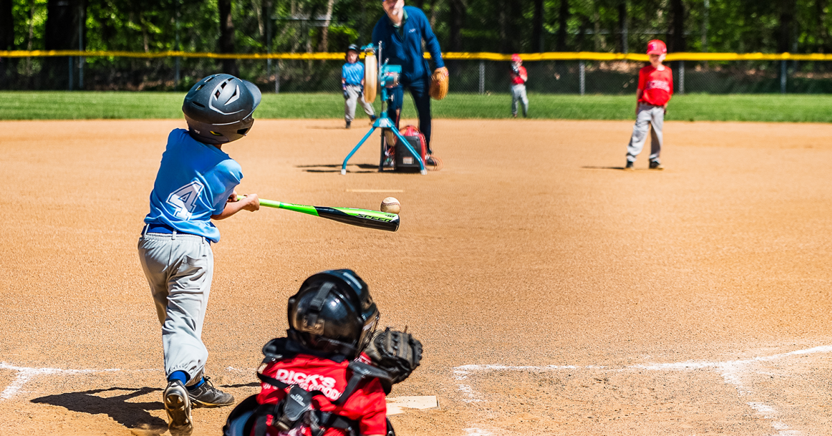

**9U Coaches Handbook**

**Spring 2025**

**Introduction**

This handbook is designed to support our volunteers in running fun and active practices / games that allow players, coaches, and parents a positive baseball experience. Volunteers are the heart of our organization. Questions are always welcome should support be needed at any time throughout the season.

In the 9U division players hitting from a full distance pitch (46’) at greater speed for the first time and off a pitching machine. This presents a new challenge in tracking the ball. This division uses basic infield position play. Each player, should have the opportunity to play each infield position each game (safety considerations are the exception).

The contents of this handbook and resources listed will help guide you through the season.

**9U Goals**

* Maximize Activity Time / Balls in Play
  + Use stations during practice to avoid down time
* Develop Basic Hitting Skills
  + Tracking & Timing
* Develop Basic Infield Position Roles
  + Covering second base (Middle Infield)
  + Throwing to the correct base (ahead of the runners)
  + Introduction to the catcher position (using a pitching machine)
* Provide a **Fun and Positive Experience**
  + No position specialization / Players Rotate Positions each inning

**9U Rules & Procedures**

1. Each team supplies two baseballs when their team is hitting.
2. Bases are 60’ apart
3. Pitching machine distance is 46’
4. Lineup cards must be presented to the Umpire and opposition Coach at a plate meeting prior to the game (if one is provided)
5. Each team must supply their own scorekeeper
6. Games are 6 Innings OR 2 hours (No new Inning is to be started after 1:45 of play)
   1. Innings consist of 3 outs or a 4-run limit (whichever is reached first)
7. **Six players per team on the field (one for each infield position). Players should rotate through each of the infield positions throughout the course of a game.**
   1. Rationale: Fly balls are rarely hit in this division and outfield play is slow and offers few opportunities for involvement.
   2. Position specialization is not a priority at this stage of development. Playing multiple positions offers the greatest opportunity for development (safety is always a consideration)
8. All players are included in the hitting line-up
9. A team may compete with less than 6 players should it be required; **empty slots are not considered outs**
10. Opposing teams may share a player, should they have more than 6 players
11. Coaches (maximum of 2) are allowed on the field of play to guide players and help maintain focus
    1. They must stand behind the infield and be as unobtrusive as possible
    2. Directions should be provided prior the pitch
12. An inning is completed when after three outs or 4 runs. (whichever happens first)
    1. Rationale: Defensive awareness is developed and hitting / baserunning opportunities given to each player every inning
13. **Each hitter receives 4 pitches. If the ball is not hit within 4 pitches a tee will be placed (in front of the plate) and they will attempt to hit the ball from the tee.**
    1. Rationale: Though some players at this level are advanced, many take time to adjust to the new distance and speed of pitches. The tee adds base running, defensive play, and excitement to the game.
    2. Pitcher must stand behind the mound for safety
    3. Each player receives three attempts to hit a fair ball from the tee (a hit must travel 10 feet)
    4. Failure to hit a fair ball in two attempts results in an “out”
14. **Baserunners may only score on a batted ball.**
    1. Players may not steal home, score on a passed ball, or overthrow back to the pitcher
    2. If an attempt to score is the continuation of an ongoing play, the runner is permitted to score (ex. A runner is on second base and the ball is hit into the field, etc.)
       1. Rationale: Simplified introduction to the catcher position offers more opportunities to hit / play defense as the run limit is not attained as quickly.
15. Players may not advance to second base on an overthrow to first base
    1. Rationale: This offers greater coaching / practice opportunities in one of the most common baseball situations (covering second base / double play)
16. Stealing is not permitted

**Field Management / Coaching Strategies**

1. Recruit parents / family members to help on the field
   1. Coaches may be on the field during games (behind players) to assist with attention, directions, and safety
   2. More people involved creates greater sense of community
2. Small group stations in practices (i.e. Hitting wiffle balls, Grounders, Fly Balls, Catching, etc.)
   1. Reduces lines / waiting (80% Activity / 20% Explanation)
   2. Allows multiple skills to be practiced simultaneously (throwing, running, hitting)
   3. Increases practice opportunities / touches of the ball
   4. Increases one on one feedback
3. Offer consistent positive feedback
   1. Sandwich technique to correct mistakes (positive, corrective, encouragement)
   2. Body Language means a lot (fist bumps, thumbs up, smiles, etc.)
   3. Acknowledge successes and efforts with positive comments