

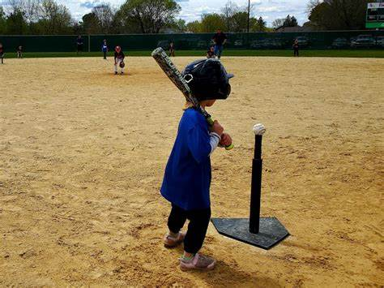

**5U Coaches Handbook**

**Spring 2025**

**Introduction:**

This handbook is designed to support volunteers in running fun and active practices / games that provide players and coaches a positive first experience. Volunteers are the backbone of PGYBA, so we hope this helps prepare you for the season to come.

Positive energy, cheering, and high fives when players cross home plate go a long way to achieving our goals. Best wishes for a fun season.

**5U Goals:**

* Minimize downtime at the younger ages
* Familiarize players with how to stand / swing in relation to home plate
* Basic Knowledge of Rules / Gameplay
  + Direction of the bases
  + Throwing to 1st Base
* Develop the habit of watching the ball and a general comfort with having a ball thrown to them
* FUN!!!

**5U Procedures / Rules:**

* There are 3 teams schedules for each session / game (teams rotate between each station throughout the session after each player has hit / fielded the ball)
  1. Hitting Team
     1. Each player hits off the tee each inning; they advance one base per hit
     2. The last player to hit each inning hits a ‘Home Run” and runs around all the bases
  2. Fielding Team
     1. Each player fields one ball per inning; if the hitting team has fewer players, someone will take an extra at-bat to allow for each player to field a ball
     2. Prior to the hit, the coach of the fielding team will assign a fielder to avoid all players rushing for the ball
     3. The fielder throws the ball to a coach / parent at 1st base
  3. Practice Station (Outfield area beyond 2nd base)
     1. This is used for fun games to help players develop comfort catching / throwing the ball
     2. Activities can include, but are not limited to the following:
        + Hot Potato
          - [How to Play the Hot Potato Game with Kids - Empowered Parents](https://empoweredparents.co/hot-potato-game/)
        + Rubber Band Throwing / Catching
          - Players stand 3-5 feet apart and toss the ball underhand to their partner
          - If the ball is caught, they take a step back; if dropped they remain in place The goal is to gradually increase the distance at which they can throw / catch
        + Self Toss
          - Players try to toss the ball in the air and try to catch it themselves
          - Start with a low toss and try to gradually increase the height of the toss
          - The goal is to get as many in a row as possible
          - Challenge can be increased by asking players to clap while the ball is in the air
        + Relay Races and / or Tag Games (Promotes Running)
          - [17 Fun Tag Games For PE to Stay Active](https://kidactivities.net/fun-tag-games-for-pe/)
  4. Repeat Cycle until each team has completed each station 3 Times / Innings

**Field Set-Up / Management**

* Place portable bases approx. 40-50 feet apart (15 paces)
* Tee at home plate
  + Ensure proper tee placement: [Baseball tutorial for kids: T-ball Swing (Batting for kids)](https://www.youtube.com/watch?v=mC1DzWdjsRs)
* The coach of each team remains with their group (i.e. at the tee, fielding, or at the practice station)
* Recruit / Invite 2-4 Parents to assist on-field at catch balls at first base, direct players to run to the next base, keep kids waiting to hit ready and organized
* Fielding team should stand in a straight line spanning between 1st and 3rd base facing home plate; coaches will assign the player to field each hit

**Questions**

Please direct any questions or concerns to PGYBA at [info@pgyba.ca](mailto:info@pgyba.ca)