

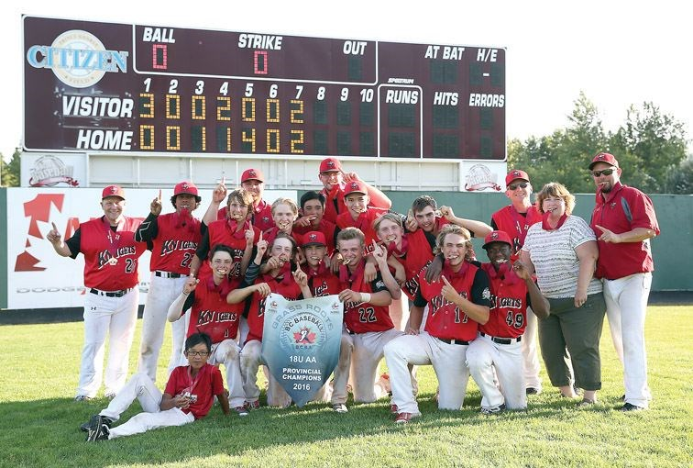

11U Coaches Handbook
Spring 2025

Introduction
This handbook is designed to support our volunteers in running fun and active practices / games that allow players, coaches, and parents a positive experience. Volunteers are the heart of our organization. Questions are always welcome when support is required.
In the 11U division players are pitching for the first time. This presents new challenges not just in pitching, but in hitting approach and number of defensive opportunities. This division uses basic position play. Focusing on position specialization should be avoided (safety considerations are the exception).
The contents of this handbook and resources listed will help guide you through the season.

U11 (Mosquito) Goals
- Maximize Activity Time & Balls in Play
  - Use stations during practice to avoid down time
- Develop Basic Pitching Skills
  - Wind-up / Delivery Sequence
- Develop Basic Positional Roles
  - Relay on balls hit to the outfield
  - Covering second base (Middle Infield)
  - Throwing to the correct base (ahead of the runners)
- Provide a Fun and Positive Experience
  - No position specialization
  - Opportunity to pitch for all those willing

11U Rules & Procedures

- Each team supplies two new baseballs to the umpire prior to the game.
- Bases are set 60’ apart
- Pitching Distance is 46’
- Lineup cards must be presented to the Umpire and opposition Coach at a plate meeting prior to the game
- Each team must supply their own scorekeeper
- Games are 6 Innings OR 2 hours (No new Inning is to be started after 1:45 of play)
  - Innings consist of 3 outs or a 4-run limit (whichever comes first)
  - The 6th inning of a game is the “open inning” where run limits do not apply (If the time limit is reached prior to the 6th inning, the open inning is not played)
- Nine players per team on the field. Players should rotate positions throughout the course of a game.
  - Rationale: Position specialization is not a priority at this stage of development and all players should build an awareness of multiple positions (safety is always a consideration)
- All players are included in the hitting line-up
- A team may compete with less than 9 players should it be required; empty slots are not considered outs
  - Opposing teams may share a player, should one team have more than 9 players
- Coaches (maximum of 2) are allowed on the field of play to guide players and help maintain focus
  - They must stand behind the infield and be as unobtrusive as possible
  - Directions should be provided prior the pitch

- An inning is completed after 3 outs or 4 runs are scored (whichever comes first).

- If a hitter receives 4 balls (a walk) a tee will be placed (in front of the plate) and they will attempt to hit the ball from the tee in lieu of a walk.
  - Rationale: Though some players at this level are advanced, few strikes are thrown at this level. The tee adds swings for batters, natural opportunities for defensive play, and excitement to the game.
  - Pitcher must stand behind the mound for safety with their eyes on the ball
  - Each player receives three attempts to hit a fair ball (a hit must travel 10 feet)
  - Failure to hit a fair ball in three attempts results in an “out”

- Baserunners may only score on a batted ball.
  - Players may not steal home, score on a passed ball / wild pitch, or overthrow back to the pitcher
  - If an attempt to score is the continuation of an ongoing play, the runner is permitted to score (ex. A runner is attempting to get to third base and the throw to third is overthrown, they may continue home, etc.)
    - Rationale: this rule offers more opportunities to hit / play defense as the run limit is not attained as quickly.

- Players may not advance to second base on an overthrow to first base
  - Rationale: This offers greater coaching / practice opportunities in one of the most common baseball situations (double play)

- Stealing is permitted
  - Players may not leave the base until the ball has crossed home plate

- Pitch count limits / rest schedules are in effect (All-Star Participation needs to be considered); Please ask scorekeepers to track pitch counts.
  - Division 11U
    - 1-25 Pitches = No Rest
    - 26-40 Pitches = 2 Nights Rest
    - 41-55 Pitches = 3 Nights Rest
    - 56-65 Pitches = 4 Nights Rest
    - 66-75 Pitches = 5 Nights Rest

Field Management / Coaching Strategies

- Recruit parents / family members to help on the field
  - Coaches may be on the field during games (behind players) to assist with attention, directions, and safety
  - More people involved creates greater sense of community

- Use game situation to guide player opportunities
  - Large lead / deficit offers opportunities to try a first-time pitcher
  - Lighter hitting players leading off an inning offer an opportunity to try inexperienced infielders
  - Players progress through the season; what was a safety consideration at the start of the season may not be the case later in the season
  - Etc.

- Small group stations in practices (i.e Pitching, grounders, fly-balls, etc.)
  - Reduces lines / waiting (80% Activity / 20% Explanation)
  - Allows multiple skills to practiced simultaneously (throwing, running, hitting)
  - Increases practice opportunities
  - Increases one on one feedback

- Offer consistent positive feedback
  - Sandwich technique to correct mistakes (positive, corrective, encouragement)
  - Body Language means a lot (fist bumps, thumbs up, smiles, etc.)
  - Acknowledge successes and efforts with positive comments

